**16 Channel Multifunction RS485 Module commamd**

**This product supports two kinds of instructions, AT command (ASCII code) and MODUBS RTU command (HEX format).**

**Automatic recognition of two kinds of commamds,no need to switch..**

**AT command (ASCII characters)**

Note:

1 In the AT command mode slave ID is invalid

2 AT commands must be uppercase, lowercase invalid

9600 Band ,8 Data bits,None Parity,1 Stop Bit

Read Status:

Channel 1: AT+R1

Channel 2: AT+R2

Channel 3: AT+R3

Channel 4: AT+R4

Channel 5: AT+R5

Channel 6: AT+R6

Channel 7: AT+R7

Channel 8: AT+R8

Channel 9 ：AT+R9

Channel 10：AT+RA

Channel 11：AT+RB

Channel 12：AT+RC

Channel 13：AT+RD

Channel 14：AT+RE

Channel 15：AT+RF

Channel 16：AT+RG

Open :

Channel 1 : AT+O1

Channel 2 : AT+O2

Channel 3: AT+O3

Channel 4: AT+O4

Channel 5: AT+O5

Channel 6: AT+O6

Channel 7: AT+O7

Channel 8: AT+O8

Channel 9 ：AT+O9

Channel 10：AT+OA

Channel 11：AT+OB

Channel 12：AT+OC

Channel 13：AT+OD

Channel 14：AT+OE

Channel 15：AT+OF

Channel 16：AT+OG

Close:

Channel 1 : AT+C1

Channel 2 : AT+C2

Channel 3 : AT+C3

Channel 4 : AT+C4

Channel 5: AT+C5

Channel 6: AT+C6

Channel 7: AT+C7

Channel 8: AT+C8

Channel 9 ：AT+C9

Channel 10：AT+CA

Channel 11：AT+CB

Channel 12：AT+CC

Channel 13：AT+CD

Channel 14：AT+CE

Channel 15：AT+CF

Channel 16：AT+CG

Toggle (Self-locking)

Channel 1: AT+T1

Channel 2: AT+T2

Channel 3: AT+T3

Channel 4: AT+T4

Channel 5: AT+T5

Channel 6: AT+T6

Channel 7: AT+T7

Channel 8: AT+T8

Channel 9 ：AT+T9

Channel 10：AT+TA

Channel 11：AT+TB

Channel 12：AT+TC

Channel 13：AT+TD

Channel 14：AT+TE

Channel 15：AT+TF

Channel 16：AT+TG

Latch (Inter-locking)

Channel 1: AT+L1

Channel 2: AT+L2

Channel 3: AT+L3

Channel 4: AT+L4

Channel 5: AT+L5

Channel 6: AT+L6

Channel 7: AT+L7

Channel 8: AT+L8

Channel 9 ：AT+L9

Channel 10：AT+LA

Channel 11：AT+LB

Channel 12：AT+LC

Channel 13：AT+LD

Channel 14：AT+LE

Channel 15：AT+LF

Channel 16：AT+LG

Momentary (Non-locking)

Channel 1: AT+M1

Channel 2: AT+M2

Channel 3: AT+M3

Channel 4: AT+M4

Channel 5: AT+M5

Channel 6: AT+M6

Channel 7: AT+M7

Channel 8: AT+M8

Channel 9 ：AT+M9

Channel 10：AT+MA

Channel 11：AT+MB

Channel 12：AT+MC

Channel 13：AT+MD

Channel 14：AT+ME

Channel 15：AT+MF

Channel 16：AT+MG

Delay

Channel 1: AT+D1=XXXX

Channel 2: AT+D2=XXXX

Channel 3: AT+D3=XXXX

Channel 4: AT+D4=XXXX

Channel 5: AT+D5=XXXX

Channel 6: AT+D6=XXXX

Channel 7: AT+D7=XXXX

Channel 8: AT+D8=XXXX

Channel 9：AT+D9=XXXX

Channel 10：AT+DA=XXXX

Channel 11：AT+DB=XXXX

Channel 12：AT+DC=XXXX

Channel 13：AT+DD=XXXX

Channel 14：AT+DE=XXXX

Channel 15：AT+DF=XXXX

Channel 16：AT+DG=XXXX

XXXX refers to the 0000 to 9999 figures, Unit is seconds

All Relays Open

AT+AO

All Relays Close

AT+AC

Return command : OpenX, CloseX (X = 1/2/3/4..a/B/C/D/E/F/G)

Example 1:

Send command "AT+D1=0010", Channel 1 is "Open", after delay of 10 seconds, channel 1 is "Close"

Send command "AT+D2=0100", Channel 2 is "Open", after delay of 100 seconds, channel 2 is "Close"

Example 2:

Send command "AT+L1", Channel 1 is "Open", other Channels is "Close"

Send command "AT+L2", Channel 2 is "Open", other Channels is "Close"

**MODBUS command (function code 06 is Control command,03 is Read status command)**

Note :

1 MODBUS command must be HEX

2 Slave ID (device address) must be correct, the default slave address is 01.

3 If you don't remember the Slave ID, use the command Read Slave ID : FF 03 00 FF 00 01 A1 E4

9600 Band ,8 Data bits,None Parity,1 Stop Bit。

**MODBUS** 06 Command (**Control command** ,HEX):

|  |  |  |  |  |  |  |  |  |
| --- | --- | --- | --- | --- | --- | --- | --- | --- |
| Bytes Number | 1 | 2 | 3 | 4 | 5 | 6 | 7 | 8 |
| MODBUS Definitions | Slave ID | Function | Address | | Data | | CRC Check | |
| Function | Device Address | Function | Channel number | | Command | Delay time | CRC Check | |
| Open | 0x00-0xFE | 0x06 | 0x0001-  0x0010 | | 0x01 | 0x00 | 2Bytes CRC | |
| Close | 0x00-0xFE | 0x06 | 0x0001-  0x0010 | | 0x02 | 0x00 | 2Bytes CRC | |
| Toggle (Self-locking) | 0x00-0xFE | 0x06 | 0x0001-  0x0010 | | 0x03 | 0x00 | 2Bytes CRC | |
| Latch Inter-locking) | 0x00-0xFE | 0x06 | 0x0001-  0x0010 | | 0x04 | 0x00 | 2Bytes CRC | |
| Momentary (Non-locking) | 0x00-0xFE | 0x06 | 0x0001-  0x0010 | | 0x05 | 0x00 | 2Bytes CRC | |
| Delay | 0x00-0xFE | 0x06 | 0x0001-  0x0010 | | 0x06 | 0x00-0xff | 2Bytes CRC | |
| Open all | 0x00-0xFE | 0x06 | 0x0000 | | 0x07 | 0x00 | 2Bytes CRC | |
| Close all | 0x00-0xFE | 0x06 | 0x0000 | | 0x08 | 0x00 | 2Bytes CRC | |
|  |  |  |  | |  |  |  | |
| Baud rate | 0x00-0xFE | 0x06 | 0x00FE | | 0x00 | 0x00-0x05 |  | |
| Slave ID(Device Address) | 0x00-0xFE | 0x06 | 0x00FF | | 0x00 | 0x00-0xfe |  | |

Remarks:

1 Momentary mode, delay time is 1 seconds

2 Delay mode, delay time is 0-255 seconds

Return command：

Command is active, return to send commands; instruction is invalid no return.

**MODBUS** 03 Command (**Read status command** ,HEX):

|  |  |  |  |  |  |  |  |  |
| --- | --- | --- | --- | --- | --- | --- | --- | --- |
| Bytes Number | 1 | 2 | 3 | 4 | 5 | 6 | 7 | 8 |
| MODBUS Definitions | Slave ID | Function | Address | | Data | | CRC Check | |
| Function | Device Address | Function | Starting register address | | Register length | | CRC Check | |
| Read Channel 1 State | 0x00-0xFE | 0x03 | 0x0001 | | 0x0001 | |  | |
| Read Channel 2 State | 0x00-0xFE | 0x03 | 0x0002 | | 0x0001 | |  | |
| Read 2 consecutive channels status | 0x00-0xFE | 0x03 | 0x0001-0x0003 | | 0x0002 | |  | |
| Read 3 consecutive channels status | 0x00-0xFE | 0x03 | 0x0001-0x0002 | | 0x0003 | |  | |
| Read 16 consecutive channels status | 0x00-0xFE | 0x03 | 0x0001 | | 0x0010 | |  | |
|  |  |  |  | |  | |  | |
| Baud rate | 0x00-0xFE | 0x03 | 0x00FE | | 0x0000-0x0005 | |  | |
| Slave ID(Device Address) | 0xFF | 0x03 | 0x00FF | | 0x0000-0x00fe | |  | |

Read status command returns (function code 03, HEX format):

|  |  |  |  |  |  |
| --- | --- | --- | --- | --- | --- |
| Bytes length | 1 | 1 | 1 |  | 2 |
| MODBUS Definitions | Slave ID | Function | data length | data | CRC16 Check |
| Function | Device Address | Function | data length | Relay state  0x0001 open  0x0000 close | CRC16 Check |
| Channel 1  open | 0x00-0xFE | 0x03 | 0x02 | 0x0001 |  |
| Channel 1  close | 0x00-0xFE | 0x03 | 0x02 | 0x0000 |  |
| Channel 2  open | 0x00-0xFE | 0x03 | 0x02 | 0x0001 |  |
| Channel 2  close | 0x00-0xFE | 0x03 | 0x02 | 0x0000 |  |
| Channel 1 open  Channel 2 open | 0x00-0xFE | 0x03 | 0x04 | 0x0001 0x0001 |  |
| Channel 1 open  Channel 2 close | 0x00-0xFE | 0x03 | 0x04 | 0x0001 0x0000 |  |
| Channel 1 close  Channel 2 open | 0x00-0xFE | 0x03 | 0x04 | 0x0000 0x0001 |  |
| Channel 1 close  Channel 2 close | 0x00-0xFE | 0x03 | 0x04 | 0x0000 0x0000 |  |

MODBUS commands you can use "Modbus Poll" input, as shown below

（CRC check generated automatically）

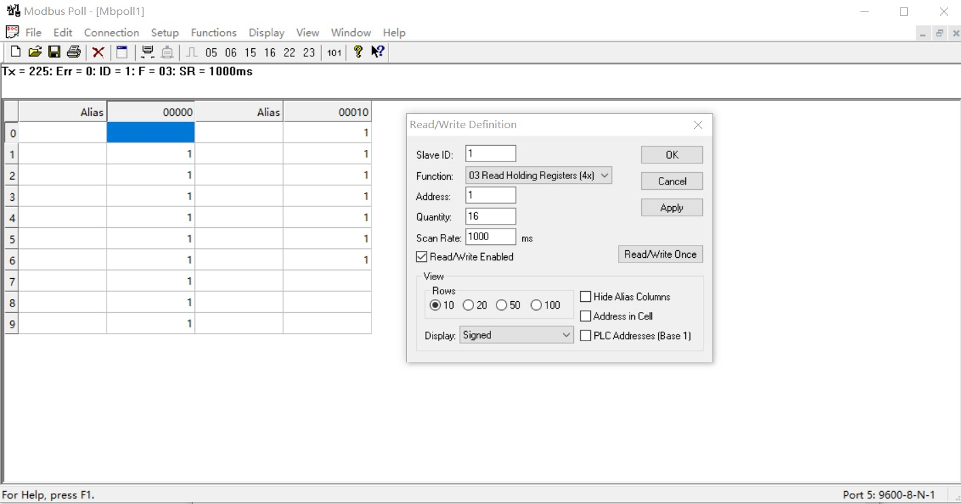

You can also use HyperTerminal serial input, as shown below

（Manually add CRC check）

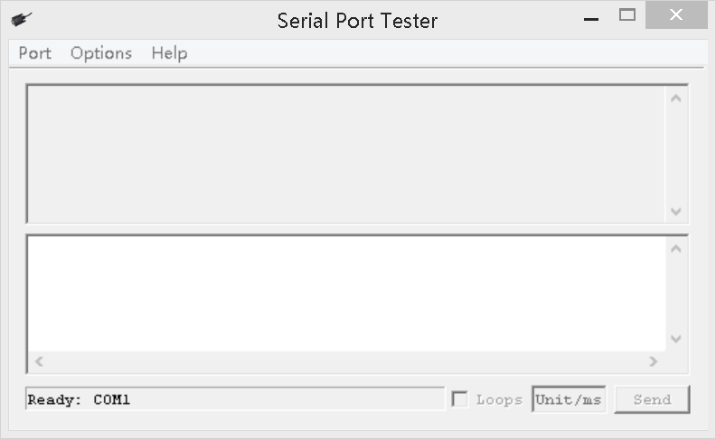

Examples (Slave ID is 1)

Channel 1 Open ：01 06 00 01 01 00 D9 9A

Channel 1 Close ：01 06 00 01 02 00 D9 6A

Channel 1 Toggle：01 06 00 01 03 00 D8 FA

Channel 1 Latch：01 06 00 01 04 00 DA CA

Channel 1 Momentary: 01 06 00 01 05 00 DB 5A

Channel 1 Delay 10 seconds : 01 06 00 01 06 0A 5B AD

Channel 1 Delay 100 seconds: 01 06 00 01 06 64 DA 41

Channel 2 Open ：01 06 00 02 01 00 29 9A

Channel 2 Close ：01 06 00 02 02 00 29 6A

Channel 2 Toggle ：01 06 00 02 03 00 28 FA

Channel 2 Latch ：01 06 00 02 04 00 2A CA

Channel 2 Momentary : 01 06 00 02 05 00 2B 5A

Channel 2 Delay 10 seconds : 01 06 00 02 06 0A AB AD

Channel 2 Delay 100 seconds : 01 06 00 02 06 64 2A 41

Open all：01 06 00 00 07 00 8B FA

Close all：01 06 00 00 08 00 8E 0A

Read state (assuming that the channel 1 is open, the channel 2 is close).

Read channel 1 state ：01 03 00 01 00 01 D5 CA

Return open：01 03 02 00 01 79 84

Read channel 2 state ：01 03 00 02 00 01 25 CA

Return close：01 03 02 00 00 B8 44

Read channel 1 and channel 2 state ：01 03 00 01 00 02 95 CB

Return channel open and channel 2 close ：01 03 04 00 01 00 00 AB F3

Read channel 1-16 state： 01 03 00 01 00 10 15 C6

Returns all channel states (all open)：01 03 20 00 01 00 01 00 01 00 01 00 01 00 01 00 01 00 01 00 01 00 01 00 01 00 01 00 01 00 01 00 01 00 01 AF 0C

Returns the status of all channels (all closed)：01 03 20 00 00 00 00 00 00 00 00 00 00 00 00 00 00 00 00 00 00 00 00 00 00 00 00 00 00 00 00 00 00 00 00 92 7A

**Set the baud rate**

1. **Read baud rate**

Send data

|  |  |  |  |  |
| --- | --- | --- | --- | --- |
| Slave ID(Device Address)  (1) | Function (1) | Register address (2) | Read number (2) | CRC16(2) |

Returns data

|  |  |  |  |  |
| --- | --- | --- | --- | --- |
| Slave ID(Device Address)  (1) | Function (1) | Number of bytes (1) | data (n) | CRC16(2) |

Function code 0x03

Slave ID : 0x01~0xFE

Register address：0x0003

Read number：0x0001

For example:

send data(Slave ID is 1)：01 03 00 FE 00 01 E5 FA

Returns data：01 03 02 00 03 F8 45

01 RS485 address，03 Function，02 length，F8 45 crc16

03 means the current baud rate is 9600bps

Baud rate corresponds to the number: 0: 1200 1: 2400 2: 4800 3: 9600 4: 19200

1. **Write baud rate**

Send data

|  |  |  |  |  |
| --- | --- | --- | --- | --- |
| Slave ID(Device Address)  (1) | Function (1) | Register address (2) | Setting Content (2) | CRC16(2) |

Returns data

|  |  |  |  |  |
| --- | --- | --- | --- | --- |
| Slave ID(Device Address)  (1) | Function (1) | Register address  (2) | Register value (2) | CRC16(2) |

Function code 0x06

Slave ID : 0x01~0xFE

Register address：0x00FE

Setting Content：2Bytes(0-4)

For example, Change the baud rate to 4800bps:

send data(Slave ID is 1)：01 06 00 FE 00 02 69 FB

Returns data：01 06 00 FE 00 02 69 FB

Baud rate corresponds to the number: 0: 1200 1: 2400 2: 4800 3: 9600 4: 19200

5: Factory reset

Note: 1 The baud rate will be updated when the module is powered up again!

2 The factory setting can be restored when the baud rate corresponding to the number is 5. For example: 01 06 00 FE 00 05 28 39

**Set Slave ID(Device Address)**

1. **Read Slave ID**

Send data

|  |  |  |  |  |
| --- | --- | --- | --- | --- |
| Slave ID  (Broadcast address)  (1) | Function (1) | Register address (2) | Read number (2) | CRC16(2) |

Returns data

|  |  |  |  |  |
| --- | --- | --- | --- | --- |
| Slave ID  ( Broadcast address )  (1) | Function (1) | Number of bytes (1) | data (n) | CRC16(2) |

Broadcast address 0xff

Function code 0x03

Register address：0x00FF

Read number：0x0001

For example:

send data：FF 03 00 FF 00 01 A1 E4

Returns data：FF 03 02 00 01 50 50

FF Broadcast address，03 Function，02 length，01 is the current module Slave ID, 50 50 crc16

Note: When using this command, only one temperature module can be connected to the RS485 bus, more than one will be wrong!

1. **Write Slave ID**

Send data

|  |  |  |  |  |
| --- | --- | --- | --- | --- |
| Slave ID  ( Device Address )  (1) | Function (1) | Register address (2) | Setting Content (2) | CRC16(2) |

Returns data

|  |  |  |  |  |
| --- | --- | --- | --- | --- |
| Slave ID  ( Device Address )  (1) | Function (1) | Register address  (1) | Register value (2) | CRC16(2) |

Function code 0x06

Register address：0x00FF

Setting Content：2Bytes(1-247)

For example, The current Slave ID is 1, We need to change the Slave ID to 3:

Send data(Slave ID is 1)：01 06 00 FF 00 03 F9 FB

Returns data：01 06 00 FF 00 03 F9 FB